Microsoft Word Practice File: You Make the Changes
Chapter 5: Text & Proofing

Make the changes given in the numbered paragraph below. After you are finished, compare your results with the Answer document also available from the Chapter Practice page.

1. After the end of the problem paragraphs, use the “Rand” function to create 5 paragraphs with 7 sentences each. Click back at the beginning of the new text and use a Page Break to put the new text on a second page.
2. Insert a text box into the text on the second page; choose the “Banded Quote” text box. Select the outside edge of the text box so the outline is solid, then use the Position tool in the Drawing Tools tab to position the text box at the top right of the second page. Type “This is the text I wanted to show you” into the new text box.
3. Insert a Heart shape into the second page. Make the text wrap around it in “Tight” fashion. Place it manually near the top left (just click and drag, do not use the Position feature).
4. Also on the second page, insert the photo you can download from the Practice Exercise page titled “pontaplay”; insert it into the text. Resize it so it is about half the width of the text area. Wrap the text as a “Square” around the image. Put the image in the middle of the page, again do not use the Position feature.
5. Place a Word Art graphic on the second page; choose any style you want, then type “Ponta is a Dog!” into it. Make the text wrap around the image as a square, then place the image near the bottom center of the page.
6. Below #8 on THIS page, type the symbols for the Yen, Euro, and British Pound.
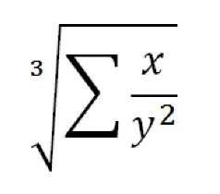
7. Again on THIS page, below the money symbols, type the equation shown in the image at right.
8. Select this problem paragraph; create a comment, and write “Cool!” in the comment box.

Type the Rand function below this line!

